LA Crab Task Force Meeting Minutes
Tuesday, January 17, 2023, 1:00pm
Terrebonne Parish Main Library
151 Library Dr. Houma, LA 70360

I. Pledge of Allegiance
II. Roll Call

Voting Members Present:
Eric Blanchard
Laquita Meek
Trudy Luke
George Jackson
Al Cassagne
Rodney Parfait
Britney Breaux

Voting Members Absent:
Chalin Delaune
Sheb Callahan
Pete Gerica
Joey Edgar
Edward Frekey
Dannon Lacoste

Non-Voting Members Present:
Peyton Cagle
Jack Isaacs
Edward Skena

Non-Voting Members Absent:
Melissa Daigle

III. Eric Blanchard motioned to approve the October 25, 2022 meeting minutes, 2nd by Trudy Luke. Motion carries.

IV. Eric Blanchard motioned to approve the January 17, 2023 meeting agenda, 2nd by Al Cassagne. Motion carries.
V. Financial Report-
Remaining Fund Balance- $427,447
Remaining Budget Balance- $276,142

Eric Blanchard motioned to approve the financial report as presented, 2nd by Trudy Luke. Motion carries.

VI. New Business

- Erin Murray of the Marine Stewardship Council (MSC) provided the task force with a presentation on ‘Making the Most of Your MSC Certification’
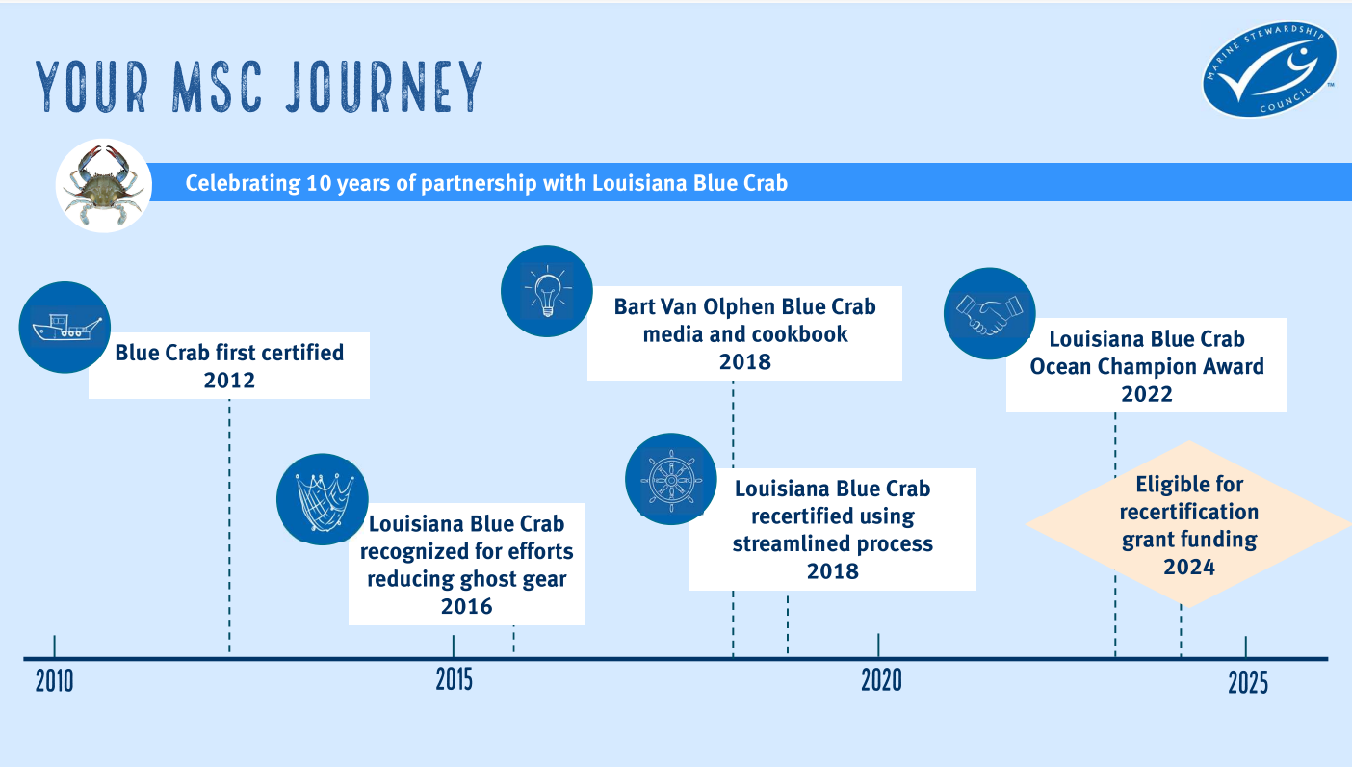
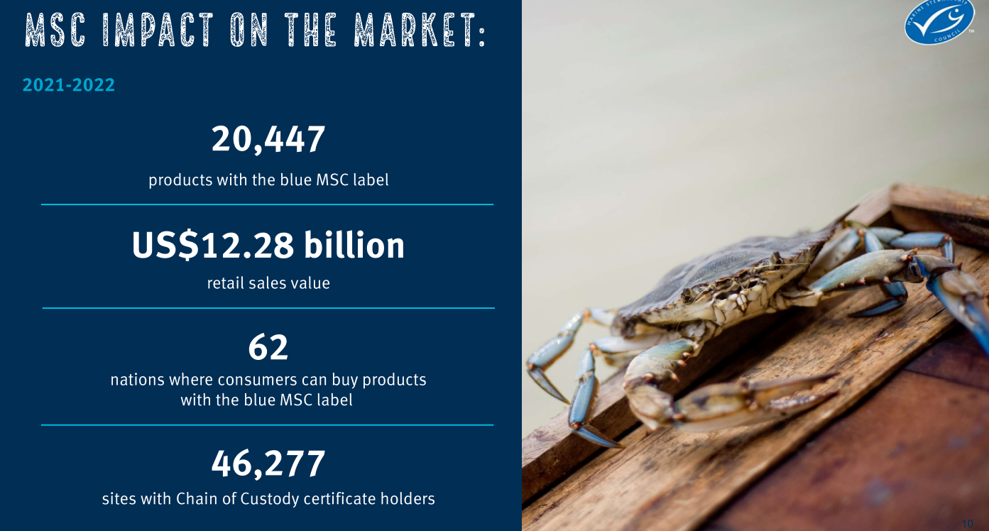

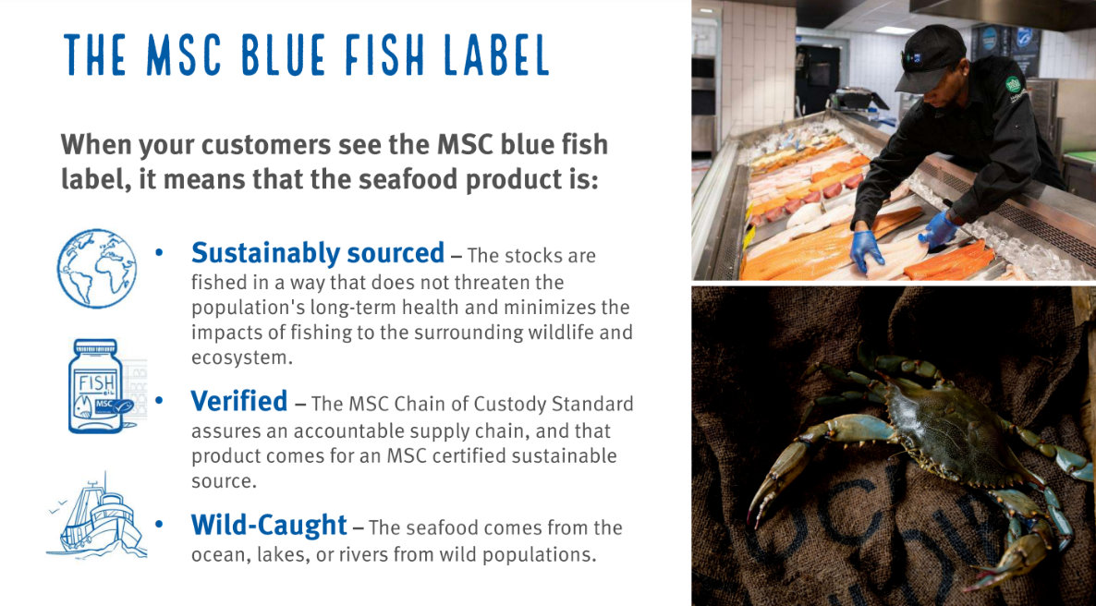
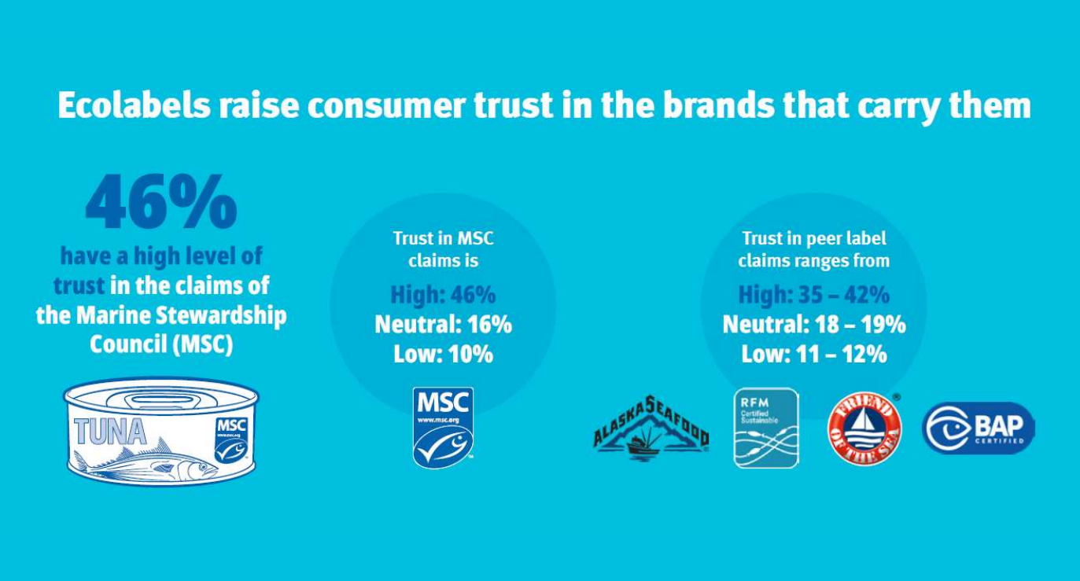
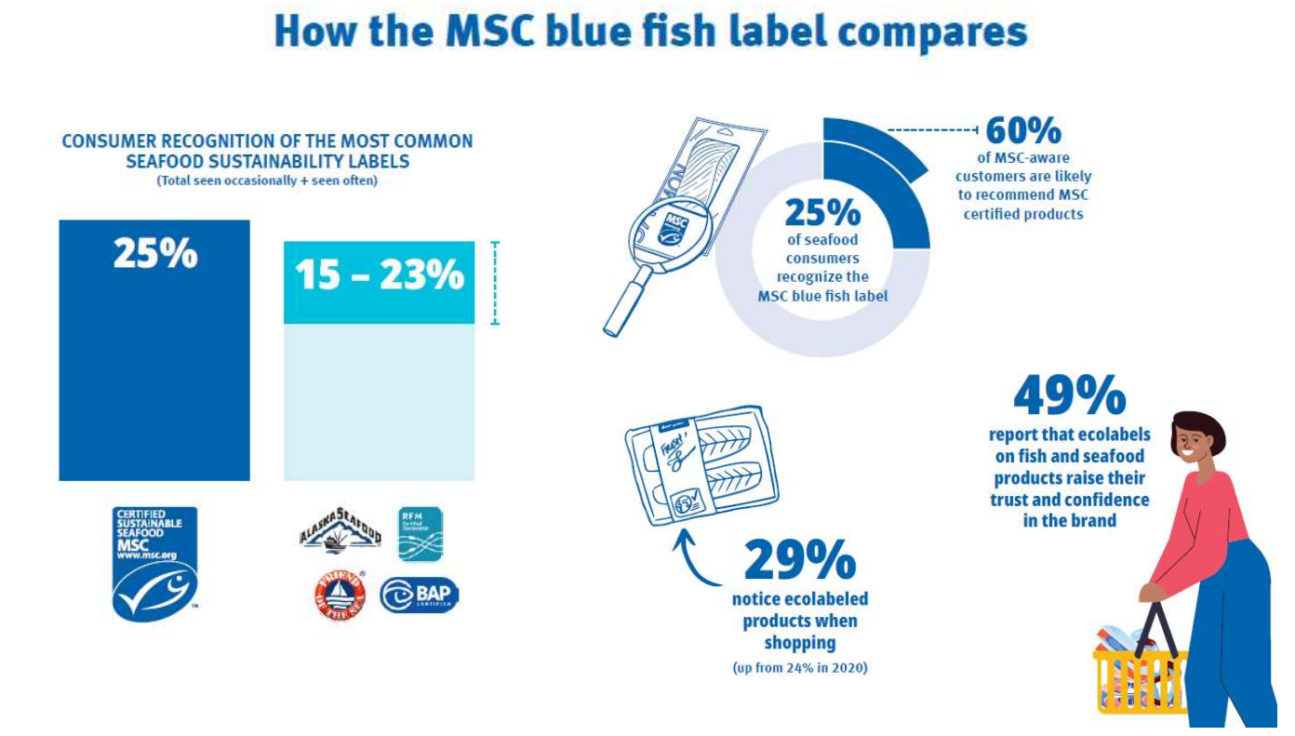

- Haley Gambill led discussion on the 2023 LA Fisheries Forward Summit panel
Topic for the panel is Opportunities for Innovation; looking for participants from the industry and need help identifying someone to serve as a panelist from the crab industry; also seeking feedback on specific ideas for discussion
- Peyton Cagle led discussion on the CSC RFM certification program
Peyton Cagle stated that that task force talked about the Gulf RFM not continuing and the funding from LDWF was ceasing for the RFM program, therefore this certification is going to lapse. There was an opportunity for the crab industry to go back for a dual certification through the continued MSC certification, looking to possibly roll in the Gulf RFM program into what is the CSC RFM, which is a larger program originally founded in Alaska. The MSC and CSC RFM rolled together looking at an additional $37,000- to combine MSC and CSC, just completed the 4th MSC audit in November, will go through reassessment next year with MSC, do you want to see the industry go back into dual certification or stay a single certification with just MSC?
Britney Breaux stated that she doesn’t see RFM for the crab industry anywhere, only see MSC when out and about, it seems like the crab industry is mostly using MSC
When will this fishery have to be assessed, regulated/ comply with the new standard for MSC, good through 2024
Al Cassagne motioned to wait on moving forward with the CSC RFM program at this time and wait until the next MSC surveillance audit to reconsider, 2nd by George Jackson. Motion carries.
- Jason Froeba provided an update on the 2019 Fisheries Disaster Funding
Plan finalized, multiple rounds of comments made, right before the holidays received the last round of edits, sent to Federal Office of Management and Budget right before the holidays for final approval, requested update and currently waiting to hear back, this should be the last step, once LDWF gets approval can start getting the programs rolled out, until approval is received cannot launch anything. As soon as approved, news releases will be sent out and public meetings will be held to spread the word about the program and application process
- Jack Isaacs provided a presentation on crabbing license data
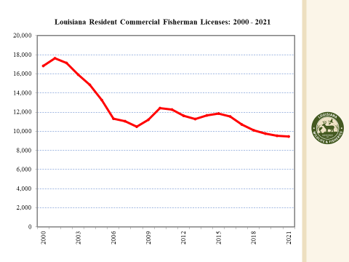
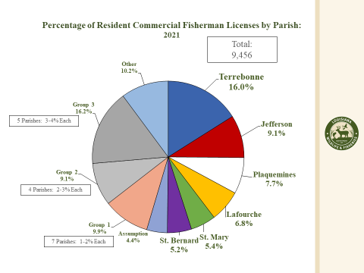
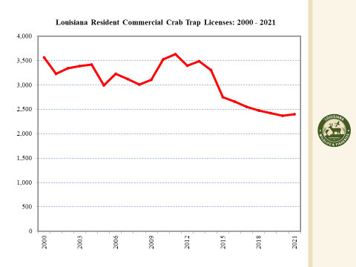
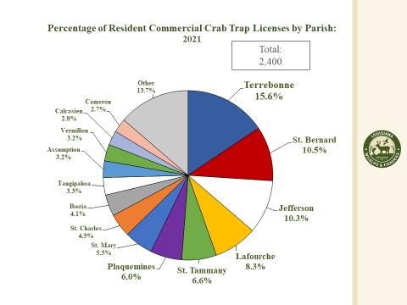
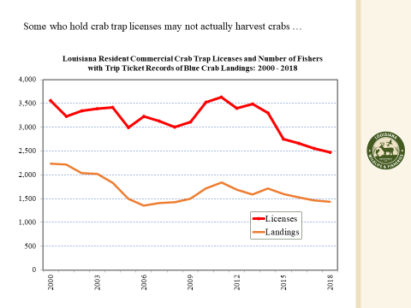
Eric Blanchard stated that the industry tried to do a moratorium on crabbing licenses in the past and it failed
Jack Isaacs stated that about 25% of the fishermen land about 75% of the crabs
Britney Breaux stated that the reason this data was requested is because there is a feeling that half the people selling crabs do not own a license, see tons of new people in the business, we have all these rules and regulations on the industry and you have all of these people actively fishing without a license and not following the rules/ regulations
Peyton Cagle stated that those who are aware of instances like Britney Breaux is mentioning needs to start reporting it to enforcement, if people are not selling their own catch and fishing without a license and then selling under someone who does have a license this needs to be reported
The task force discussed possibly adding an item to the next meeting agenda to discuss private leased fishing land
Chad Cannizarro stated that his area has issues with unauthorized people running his traps at night; would like to see more information about crabs in the apprenticeship program
The task force discussed possibly adding an item to a future meeting agenda to review the program and consider making changes to the apprenticeship program
F. Crab Task Force held officer elections
Al Cassagne motioned to postpone officer elections to a future meeting, 2nd by George Jackson. Motion carries.
VII. Public Comment:
Haley Gambill approached by a soft shell guy in North Carolina interest in meeting or contact with this guy- get info to the board
VIII. The next CTF meeting was set for Tuesday, March 28, 2023 Tuesday, September 26, 2023 for 1pm in Houma at the Terrebonne Parish Main Library
IX. Trudy Luke motioned to adjourn the meeting, 2nd by George Jackson. Motion carries.

